COS80022 – Software Quality and Testing

Report for Lab 1

Student Name: Arun Ragavendhar Arunachalam Palaniyappan
Student ID: 104837257
Student email: 104837257@student.swin.edu.au
Submission date: 03/03/2024

- User Requirements
The user requirement here is to design and develop a program that accepts a positive Integer between 1 and 365, where the integer represents a day of the year in a non-leap year context, and gives the corresponding month and day of the month as the output.
- Analysis and Design
Firstly, the entered input from the user must be validated as whether it is a positive integer between 1 and 365 or not.
Then if it passes validation, we can proceed to extract the month and particular day of the month. The logic here is to store the number of days in every month as an array of Integers and then compare the user input with it successively, using a while loop. If the user input is lesser than the number of days in the current month, then it falls within the same month. The index and the subsequent day are extracted to give an output. Else, if the user input is greater than the number of days in the current month, the user input is then subtracted by the number of days in the current month and then the while loop runs again until the desired condition is met.
Therefore, the program should follow the workflow as below.

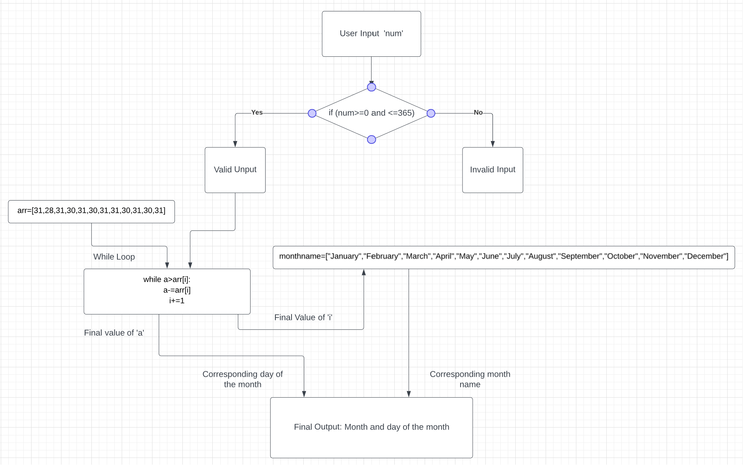

- Coding
A python program SQT_lab1.py is created for this project. The source code:
a=int(input("please enter a number "))
arr=[31,28,31,30,31,30,31,31,30,31,30,31]
monthname=["January","February","March","April","May","June","July","August","September","October","November","December"]
if (a>0 and a<=365) :
i=0
while a>arr[i]:
a-=arr[i]
i+=1

print(" month : ",monthname[i])
print(" day : ",a)

else:
print("your input is invalid . please enter only an integer between 1 and 365")

- Testing
The following test cases are designed, to be tested.
# | Input Data | Expected Result
TC1 | -5 | “your input is invalid . please enter only an integer between 1 and 365”
TC2 | 31 | “month : January  day : 31”
TC2 | 32 | “month : February  day : 1”
TC4 | 59 | “month : February  day : 28”
TC5 | 247 | “month : September  day : 4”

The execution results of the test cases are shown as below:
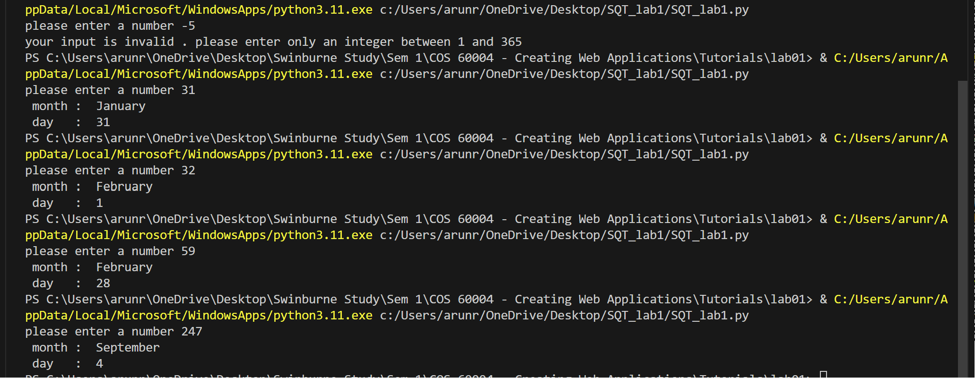

The actual execution results are consistent with the expected outputs.Hence, program has passed all the given test cases.

